
Data Security Envisioning Workshop
03-Module Delivery Guide-Teams
v8.5 - January 2026

Contents
Disclaimer 3
Version history 4
We look forward to your feedback! 4
1 Introduction 5
1.1 Objectives 5
1.2 Delivery guidance 5
1.3 Scoping 6
1.4 Estimated partner effort 6
1.5 Tools and services used 7
1.5.1 Data Loss Prevention for Teams 7
2 Activity details 8
2.1 Step 1 - Kick-off meeting 8
2.2 Step 2 - Acquire and assign licenses 8
2.3 Step 3 - Setup and configuration 9
2.3.1 Create a Data Loss Prevention Policy 9
2.4 Step 4 - Analyze the findings 12
2.5 Step 6 - Decommission 18

Disclaimer
The Data Security Envisioning Workshop provides a summary of an organization’s data protection and compliance stature and recommendations to improve data protection and compliance.
The information, results, and scoring provided through the Data Security Envisioning Workshop are recommendations and provided for general informational purposes only. They do not constitute legal advice, certifications, or guarantees regarding regulatory compliance; it is up to each organization to evaluate the effectiveness of these recommendations in their respective regulatory environment prior to implementation. Organizations should consult with their own legal professionals to determine how standards or regulations apply to their organization and how to best ensure compliance.
We hope the Data Security Envisioning Workshop helps identify technologies and additional steps that organizations can implement to simplify their compliance efforts.
MICROSOFT MAKES NO WARRANTIES, EXPRESS, IMPLIED, OR STATUTORY, AS TO THE INFORMATION IN THIS Data Security Envisioning Workshop. Microsoft disclaims any conditions, express or implied, or other terms that use of the Microsoft products or services will ensure the organization’s compliance with regulations or standards. This Data Security Envisioning Workshop toolkit is provided “as-is.” Information and recommendations expressed in the Data Security Envisioning Workshop toolkit may change without notice.
The Data Security Envisioning Workshop toolkit does not provide the user with any legal rights to any intellectual property in any Microsoft product or service. Use of the tool is for internal, reference purposes only; however, Microsoft partners may distribute the Data Security Envisioning Workshop toolkit to their customers for such customers’ internal, reference purposes only. Any distribution of the Data Security Envisioning Workshop toolkit by a Microsoft partner to its customers must include terms consistent with those set forth in this disclaimer.
© 2026 Microsoft. All rights reserved.

Version history
Version | Author | Changes | Date
3.1 | François van Hemert | First published release. | February 2021
4.0 | François van Hemert | Workshop split, update to align with new narrative, rebranding, updates to guidance and organized around data repositories. | June 2021
4.01 | François van Hemert | Updated instructions on notification setting DLP policy. | September 2021
4.1 | François van Hemert | Update illustration for Compliance Manager Premium Assessments. | October 2021
4.2 | François van Hemert | Purview branding update, step-by-step guidance update to align with changes M365. | July 2022
4.2.2 | François van Hemert | Update to align with current product features and functionality (evergreen). | January 2023
6.0 | François van Hemert | Workshop merge, align with FY24 solution play, focus on Data Security. | August 2023
6.5 | François van Hemert | Update step guidance, align with FY25 solution play. | July 2024
6.6 | François van Hemert | Update to align with the new Microsoft Purview Portal | October 2024
7.0 | François van Hemert | Updated for additional module on Generative AI | January 2025
7.1 | François van Hemert | Version number update, no further changes | May 2025
8.0 | François van Hemert | Update to align with current product features and functionality (evergreen), update name, update branding. | July 2025
8.5 | François van Hemert | Update to align with current product features and functionality (evergreen) | January 2026


We look forward to your feedback!
Thank you for your continued trust and partnership. The resources within this toolkit will be iteratively improved upon based on product releases as well as direct feedback from delivered engagements. We encourage you to provide feedback to help us improve our products and toolkits.
Please share your feedback and questions via our Engagement feedback form that can be found at: https://aka.ms/SCIEngagementsFeedback.

Introduction
This document contains delivery guidance that will extend the Automated Discovery Process to monitor Teams communications for activity related to data that might impose data security risks to the organization.
The outcome and findings of this activity will be merged into the overall findings and recommendations that will be presented at the end of the Data Security Envisioning Workshop.

Objectives
The objectives for this activity are:
- Identify data security risks in Microsoft 365 Teams chat and channel messages, including private channels.
Monitor Teams for sharing of information that can impose data security risks to the organization.
- Understand how to mitigate identified data security risks.
Help customers to better understand, prioritize, and mitigate the data security risks that were identified by Data Loss Prevention for Teams.
- Provide recommendations and define next steps.
Recommendations and next steps based on the findings from this activity will be merged into the overall Data Security Envisioning Workshop close-out presentation.

Delivery guidance
This document is an integral part of the overall delivery guidance for the Data Security Envisioning Workshop. When delivering the Data Security Check, follow the guidance provided in the 00-Master Delivery Guide and when instructed, engage in the supplemental activities outlined in this guide.
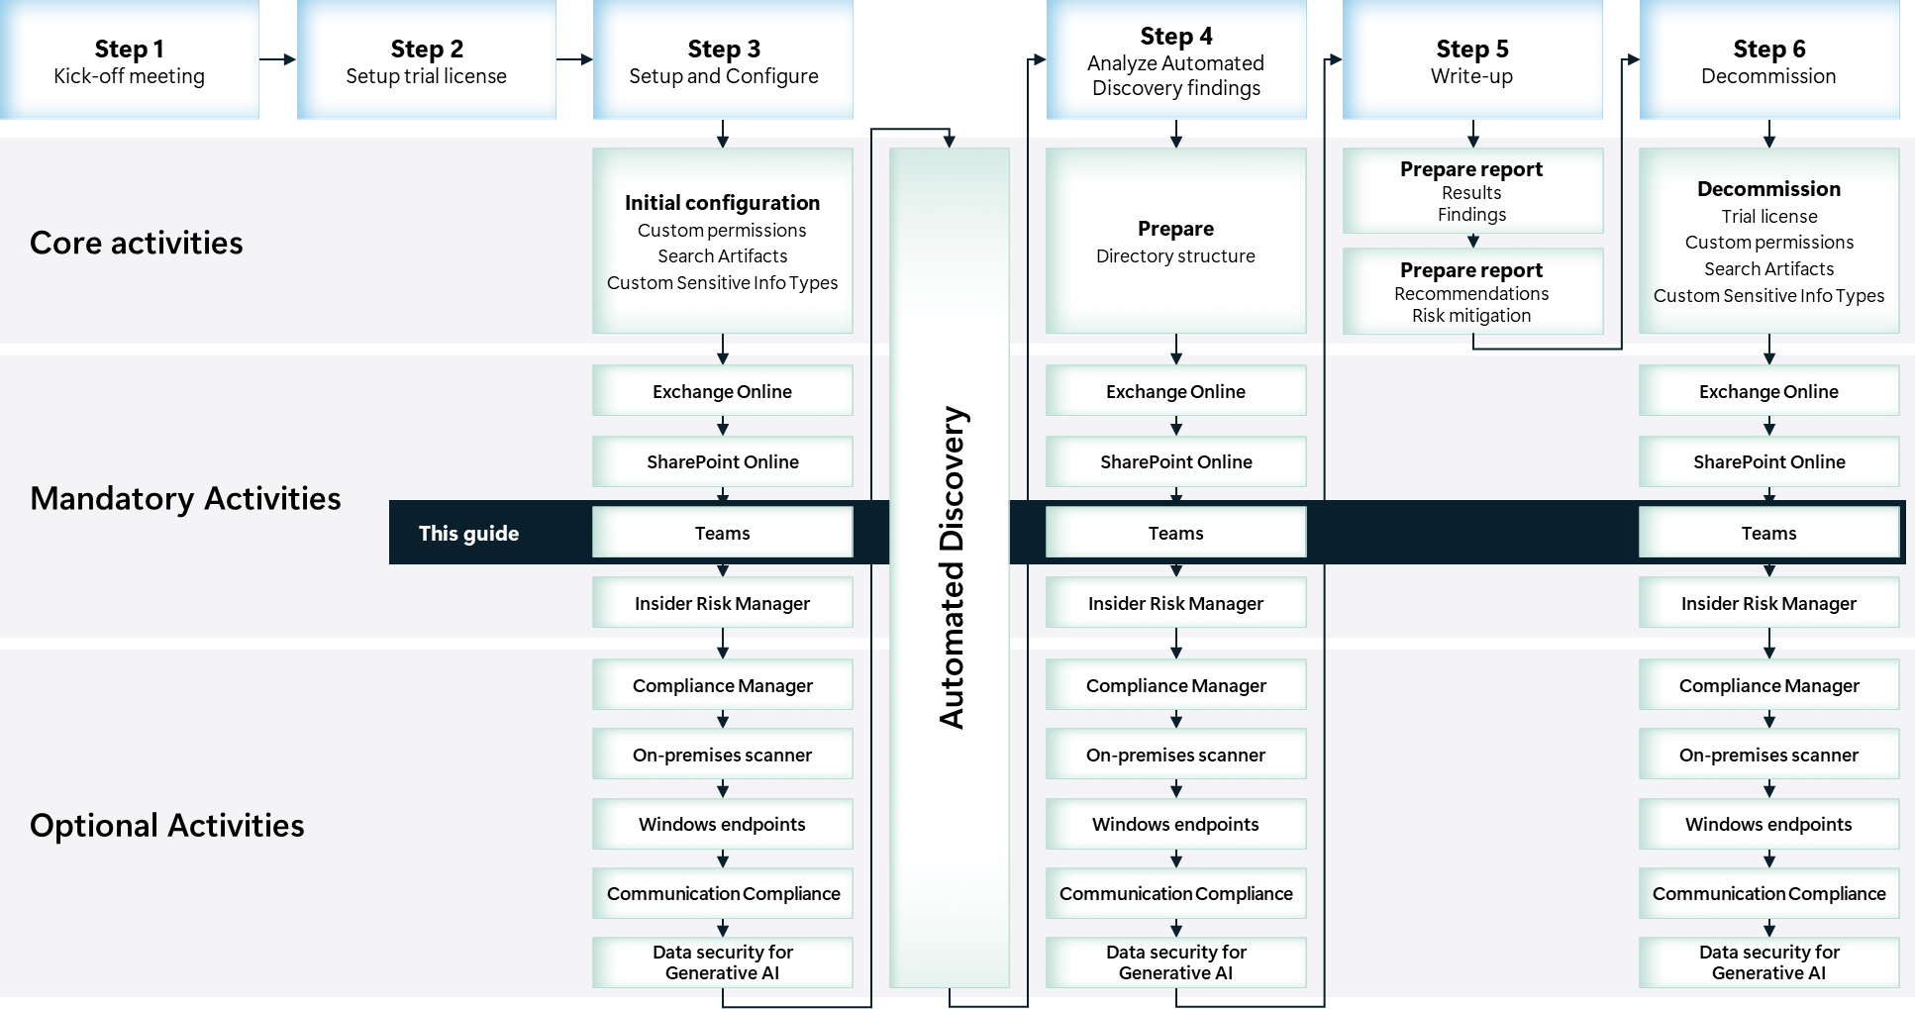

Scoping

In scope
The scope for this activity includes:
- Install and configure Data Loss Prevention for Teams, with a limited assessment configuration.
- Identify risky or unwanted behavior related to data containing sensitive information that may impose data security risks to the organization.

Estimated partner effort
The table below provides a high-level estimate of the additional partner effort for the activities described in this guide. The numbers provided are to be considered indicative and can change as a result of customization of the delivery schedule and the individual activities.
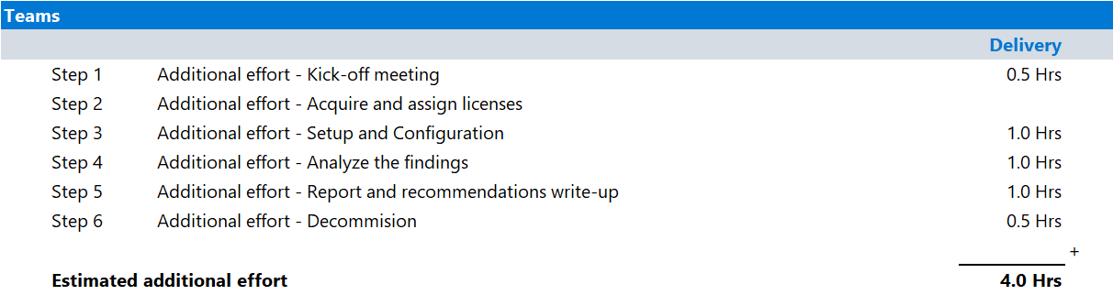

Tools and services used
The Data Security Check Automated Discovery leverages Data Loss Prevention for Teams to discover and report on data security risks originating from Teams chat and channel messages, including private channels.

Data Loss Prevention for Teams

Overview
Data Loss Prevention for Teams builds on labeling and classification capabilities in Microsoft Purview Information Protection, extending the existing Microsoft Purview Data Loss Prevention capabilities in Microsoft 365 Teams chat and channel messages. Through the use of policies, an organization can prevent people from sharing sensitive information in a Teams channel or chat session. Senders of messages benefit from this functionality by having sensitive information in their outgoing chat and channel messages inspected for sensitive information, as configured in the organization's Data Loss Prevention policy.

Product information
For more information on Data Loss Prevention for Teams, refer to:
- Data loss prevention and Microsoft Teams

Functionality used by the Data Security Check.
The Data Security Check will leverage Data Loss Prevention for Teams to:
- Identify data security risks in Teams channels or chat sessions.

Activity details

Step 1 - Kick-off meeting

Guidance
Follow the guidance for the Kick-off meeting provided in the <00-Master Delivery Guide> and add an additional section to the meeting(s) to discuss:
- The additional functionality that Data Loss Prevention for Teams will add to the Automated Discovery process.
- Which users will be enabled to for Data Loss Prevention for Teams.
- Which sensitive information types also represent a risk in real time communications and therefore should be part of the Data Loss Prevention for Teams policy.
The <40-Pre-engagement and Kickoff deck> contains optional slides with speaker notes that can be used to facilitate the discussion and document the outcome.

Supporting materials
- <40-Pre-engagement and Kickoff deck>
Note
The <40-Pre-engagement and Kickoff deck> is used for both the Pre-engagement meeting and the Kick-off meeting. Instructions on how to update the slides are included as hidden slides in the deck.

Pre-requisites
The activities and guidance described in this step complement Step 1 - Kick-off meeting as described in the <00-Master Delivery Guide>. The activities should be merged and delivered as one.

Next step
- Return to the <00-Master Delivery Guide> and continue the guidance provided in Step 1 - Kick-off meeting.

Step 2 - Acquire and assign licenses
The required product licenses for this activity are included in the overall Data Security Check trial license that was deployed in Step 2 - Acquire and assign licenses of the <00-Master Delivery Guide>. No additional (trial) licenses are required.
 Important
To access and use Data Loss Prevention for Teams functionality, all users included in the policy must be assigned a license from the Data Security Check trial.

Step 3 - Setup and configuration

Guidance
This section describes the steps required to install, configure, and run Data Loss Prevention for Teams as part of the Data Security Check.

Background reading
For more information refer to:
- Data loss prevention and Microsoft Teams

Pre-requisites
Prior to starting the activities in this step, the following mandatory Data Security Check activities as described in <00-Master Delivery Guide> should be completed:
- Step 1 - Kick-off meeting
- Step 2 - Acquire and assign licenses
- Step 3 - Setup and configuration

 Important
Data Loss Prevention for Teams relies on Sensitive Info Types to identify privacy and regulatory risks. Before starting this activity, the instructions outlined in Step 3 - Setup and configuration in the 00-Master Delivery Guide should be completed successfully. (i.e., all customer specific sensitive information types configured and available).

Create a Data Loss Prevention Policy

Guidance
A Data Loss Prevention policy in the Microsoft Purview portal enables the organization to identify, monitor, and automatically protect sensitive information across Microsoft 365.
This paragraph describes the steps to create a Data Loss Prevention policy that includes all the Sensitive Info Types, both custom and out-of-the-box, that the customer has previously identified as relevant to their organization. The Data Loss Prevention policy created for this activity is a monitor-only policy, it will not prevent sending of information containing sensitive information.

Objective(s)
- Create a Data Loss Prevention policy to be used by Data Loss Prevention for Teams to search for Sensitive Info Types based on the selection made during the Pre-engagement meeting or Kick-off meeting.

Background reading
For more information and further customization, refer to:
- Data loss prevention and Microsoft Teams
- Learn about the default data loss prevention policy in Microsoft Teams

Instructions
- Browse to the Microsoft Purview portal at https://purview.microsoft.com/ and log in with Tenant Admin credentials or a user account that is a member of your Data Security Check team and has been assigned the appropriate permissions.
- In the navigation bar on the left side, click on Solutions
- In the Solutions navigator, click on Data loss prevention.
- On the Data Loss Prevention solution card, click on Policies.
- On the Policies page, click + Create policy.
- On the Choose what type of data to protect page, select Data stored in connected sources.
- Click Next.
- On the Start with a template or create a custom policy page, below Categories, select Custom and below Regulations select Custom policy.
Note
This sample policy will search for the following default datatypes:
- Credit Card Number
- U.S. Bank Account Number
- ABA Routing Number
- All Custom Sensitive Info Types the customer has previously identified as relevant

These data types might not be applicable if your customer is in a different region or different industry. Select the templates that are applicable to your customer.

- Click Next.
- Type DataSecurityCheck-DLP-Teams as the name of the new policy and provide a meaningful Description.
- Click Next.
- On the Assign admin units page, click Next.
- Under Choose where to apply the policy, select Teams chat and channel messages, de-select all other locations.
- Click on Edit next to Teams and channel messages.
- On the Scope for teams chat and channel messages fly-out, select Specific users and groups.
- Click on + Include users and groups.
- On the Choose users and groups fly out, select all users that will participate in the Data Loss Prevention for Teams activity.
- Click Done.
- On the Choose where to apply the policy page, click Next.
- On the Define policy settings page, select Create or customize advanced DLP rules.
- Click Next.
- On the Customize advanced DLP rules page, click +Create rule.
- Type DataSecurityCheck-DLP-TeamsRule as the name of the new rule and provide a meaningful Description.
- Below Conditions, click on +Add a condition, select Content contains.
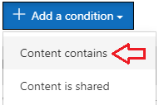
- Below Content contains, click on Add and select Sensitive info types.
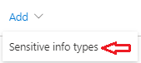
- On the Sensitive info types fly out, search for DataSecurityCheck- and select all Custom Sensitive Info Types previously created by you and your customer.
- Click on Add.
Note
The Custom Sensitive Info Types can be easily identified by searching for the <Publisher> name or by searching for the prefix <DataSecurityCheck->.
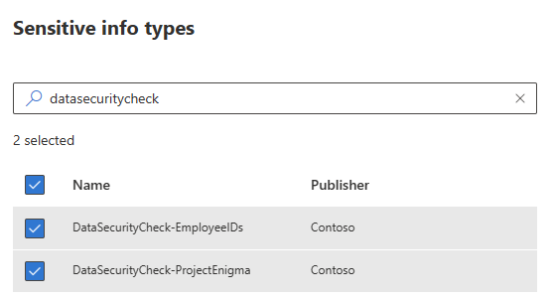

- Back on the Create rule page, below Content contains, click on Add and select Sensitive info types.

- On the Sensitive info types page, select all Out-of-box Sensitive Info Types identified by you and your customer during the Pre-engagement meeting or Kick-off meeting that can impose a risk to your customer’s real time communication.
- Click Add.
- Back on the Create rule page, verify the setting below Group operator is set to Any of These.
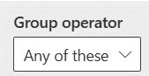
- Below User Notifications, verify the slider is set to Off.
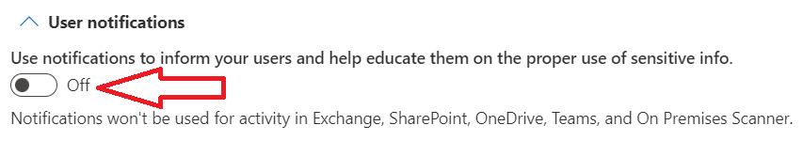
- Below Incident reports, set Send an alert to admins when a rule match occurs, and Use email incidents reports to notify you when a policy match occurs to Off.
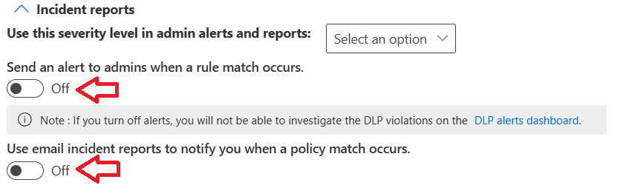
- Click Save.
- Back on the Customize advanced DLP rules page, click on Next.
- On the Policy mode page, select Turn the policy on immediately.
- Click Next.
- Review your settings and then click Submit.
- Click Done on the New policy created confirmation page.
Note
It can take up to one hour for the new policy to go into effect.

Next step
- Return to the <00-Master Delivery Guide> and continue the guidance provided in Step 3 - Setup and configuration.

Step 4 - Analyze the findings
In this step the partner will, together with the customer’s tenant / compliance administrator, analyze all logs, information, and reports generated by the different Data Security Check tools and services. This section describes the additional steps required to prepare and analyze the results from the Data Loss Prevention for Teams activity.
It is recommended to do a two-step analysis of the logfiles, reports, and findings:
- Quick scan. By using the various dashboards and preview views you will be able to identify common patterns and/or trends that need further investigation and can serve as an example of data security risks. Look for “most impactful” events related to important people within the organization, high volumes of documents related to a specific business process, Personally Identifiable Information (PII), etc.
- Detailed analysis using exported log and report files for the various services will allow for further investigation of previously identified data security risks and events flagged during the quick scan. Aim at determining the impact and risk and consider possible solutions for mitigation. During this detailed analysis, you are advised to leverage the insights of the customer team because they will know what and who to look for. To rule out “false positives” you are advised to do further investigation of all the events that will be included in the final closeout presentation at the end of the engagement.

Important
It is important to stay within the scope of this activity while analyzing the findings and identified data security risks. Unless exceptional risks are identified that require immediate action, the activities for this step should be limited to analysis and not extend to mitigation or corrective action. If corrective action or mitigation is required, this should be discussed with and approved by the customer prior to engaging on these out-of-scope activities. The objective of the Data Security Check is to highlight data security risks to the customer’s organization and to understand, learn, and advise on what can be done to mitigate these risks.

Guidance
Follow the steps outlined in this section to generate and export reports related to Data Loss Prevention for Teams.
Note
Reports for Teams Data Loss prevention may reveal personal information about the person or type of information that triggered the policy. If this is unwanted from a privacy or confidentiality perspective, it is recommended to obfuscate the data before analysis.

Objective(s)
- Generate and export the Data Loss Prevention policy matches reports.

Background reading
For more information refer to:
- Get started with Activity explorer

Pre-requisites
Prior to starting the activities in this step, the following mandatory Data Security Check activities as described in <00-Master Delivery Guide> should be completed:
- Step 1 - Kick-off meeting
- Step 2 - Acquire and assign licenses
- Step 3 - Setup and configuration
- Step 4 - Analyze the findings

Instructions
- On the local workstation, if not already done, extend the previously created directory structure by creating the \DataSecurityCheck\Teams folder.
- Browse to the Microsoft Purview portal at https://purview.microsoft.com/ and log in with Tenant Admin credentials or a user account that is a member of your Data Security Check team and has been assigned the appropriate permissions.
- In the navigation bar on the left side, click on Solutions.
- In the Solutions navigator, click on Information Protection.
- On the Information Protection solution card, expand Explorers.
- Below Explorers, click on Activity explorer.
- Click on the Selected filter set dropdown and select DLP policies that detected activities.
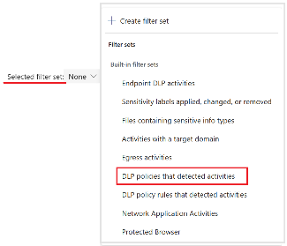

Note
By default, the dashboard shows one week of data; to view the findings of the Automated Discovery the date range should be updated to include the results of the Automated Discovery.

- On the filter option row, click on Date.
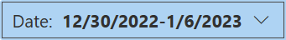
- In the Date dropdown, update the Start date and End date to include the period the Automated Discovery has been active.
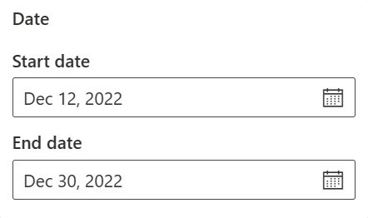
- On the filter options row, click on Activity and select DLP rule matched.
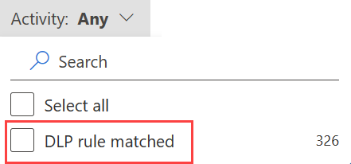
- On the filter options row, click on Location, select Microsoft Teams, leave all other selections unchecked.
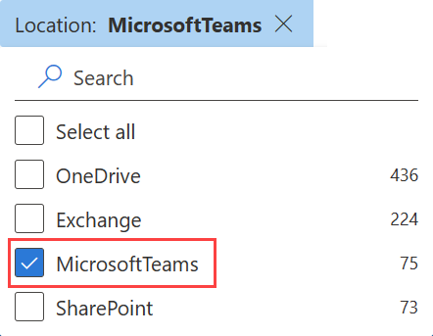
- On the filter options row, click on Policy, select DataSecurityCheck-DLP-Teams.

Note
If you do not see all of the selections in the filter row, click on + more to expand the list.

- Create a screenshot of the Data visualization for DLP rule matched.
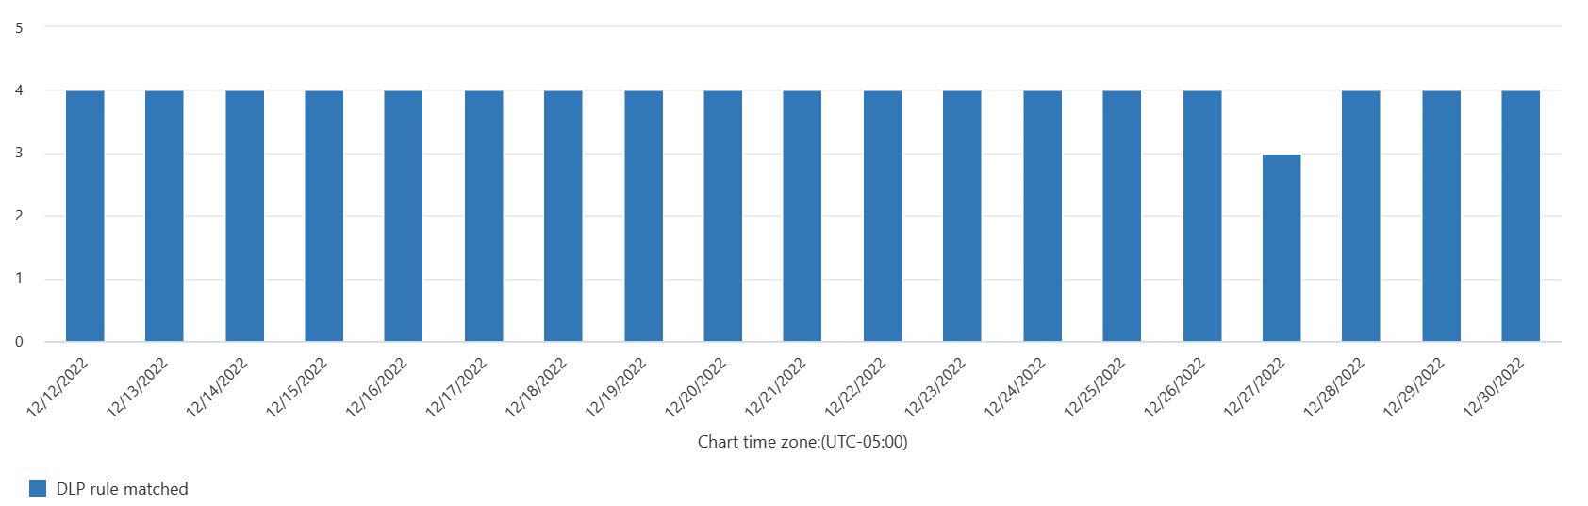

Note
Refer to Use Snipping Tool to capture screenshots for guidance on taking screenshots.

- Save the screenshot as <TeamsDLP – DLPPolicyMatches.jpg> to the\DataSecurityCheck\Teams folder for future use in the closeout presentation.
- Above the Activity details list, click Customize Columns.
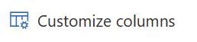
- In the Customize columns page, check Sensitive info type and Sensitive info type count to add them to the currently selected items. Leave all other selections as-is.
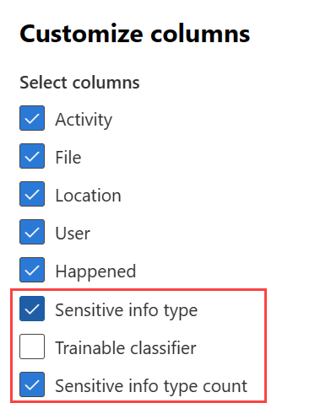
- Click Apply.
- Above the Activity details list, click on Export.
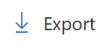
- On the browser download options choose Save as and save the csv file to the
\DataSecurityCheck\Teams folder on your local workstation. If the file automatically downloaded, you may need to retrieve the Activity Explorer – Microsoft Purview.csv file from your downloads folder.
- Import Activity Explorer – Microsoft Purview.csv into Excel following the instructions in Appendix A – Formatting CSV files in Excel in the <00-Master Delivery Guide>.
- Create a pivot table matching the definition depicted in the illustration below.
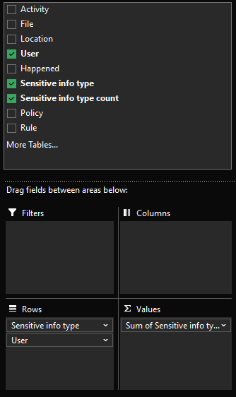 | Filters: Rules  Columns: Empty  Rows: Sensitive info type, User  Ʃ Values: Sum of Sensitive info type count  Sort: Z-A Sum of Sensitive info type count.  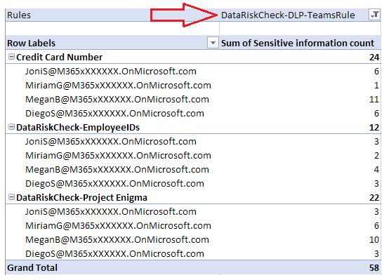
- When creating the closeout presentation, copy the pivot table to the appropriate slide in the deck.

Next step
- Return to the <00-Master Delivery Guide> and continue the guidance provided in Step 4 - Analyze the findings.

Step 6 - Decommission

Guidance
The final activity for the Data Loss Prevention for Teams activity is to decommission the services and tools used for this activity.

Objectives
The objectives for this activity are:
- Decommission the services that were installed to support the Data Loss Prevention for Teams.

Deliverables
For this activity, the following deliverables have been defined:
- All tools and services used during the Data Loss Prevention for Teams activity are decommissioned.
- All custom configuration artifacts are removed from the customer’s tenant.

Instructions – Delete custom Data Loss Prevention policies
- Browse to the Microsoft Purview portal at https://purview.microsoft.com/ and log in with Tenant Admin credentials or a user account that is a member of your Data Security Check team and has been assigned the appropriate permissions.
- In the navigation bar on the left side, click on Solutions
- In the Solutions navigator, click on Data loss prevention.
- On the Data Loss Prevention solution card, click on Policies.
- On the Policies page, select the DataSecurityCheck-DLP-Teams policy.
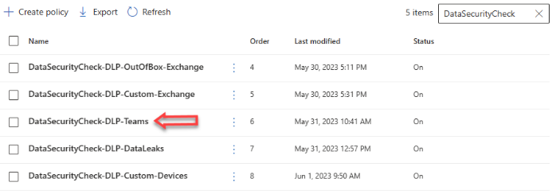
- Click on Delete Policy.
- On the Delete DLP policy pop-pup, click on Delete policy.

Next step
- Return to the <00-Master Delivery Guide> and continue the guidance provided in Step 6 - Decommission.

